Introduction to Java Mail API

How does Email works
http://www.roseindia.net/javamail/index.shtml
Each Internet domain has email Server, when a user sends an Email…
- Email client Program sends the message to Email server.
- Email server contact to the Recipient’s Email server provided in the Email address.
- Email server checks that user name is valid or not.
- If found valid send email to the address’s email server.
- When recipient log on his mail account, gets his Email.
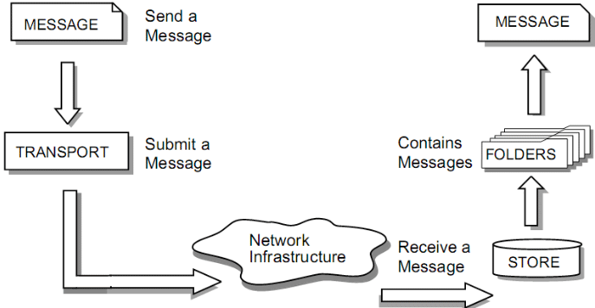

Mailing protocols
Basically, a protocol represents standard method used at each end of a communication channel, in order to properly transmit information.
Generally four protocols are used to send and receive Emails:
Simple Mail Transfer Protocol (SMTP):
SMTP is used to deliver Email to the recipient mail server. Java mail Application communicates with company’s or user’s ISP (Internet service provider) SMTP server, that SMTP Server will transfer the message to recipient SMTP Server.
POP (Post Office Protocol 3):
This protocol defines a single mailbox for a single user and a standardized way for users to access mailboxes and download messages to their computers as well. This provides facility to users to retrieve e-mail when connected. Once the messages are downloaded from the server, you can disconnect the Internet connection and read your mail.
IMAP (Internet Message Access Protocol):
IMAP is a client/server most advanced protocol in which Email is received and held for user by his Internet server. It supports both connected and disconnected modes of operation, allows multiple clients to access the same mailbox and provides server side searches.
MAPI (Messaging Application Program Interface):
MAPI is used to send Email with in windows application and provide facility to take advantage of word processors, spreadsheets, and graphics applications. One of the most popular Email applications Eudora includes a MAPI Server.

Technical description of Java Mail API

Session
Session is the top-level entry class representing mail session. It uses java.util.Properties object to get information about mail server, username, password etc. This class has a private constructor and you can get session objects through getInstance() and getDefaultInstance() methods. getDefaultInstance() method provides default Session object which takes Properties and Authenticator objects as arguments.
Properties props = new Properties();
// code to fill props with any information
Session session = Session.getDefaultInstance(props, null);
Or create a unique session by getInstance() method…
Properties props = new Properties();
// code to fill props with any information
Session session = Session.getInstance(props, null);

Message
After creating session object, create message to send by using Message class. Because of message class is abstract class so we will use subclass javax.mail.internet.MimeMessage.
MimeMessage message = new MimeMessage(session)
// set the content of message by setContent() method
message.setContent(“www.roseindia.net”, “text/plain”);
We can also use setText() method to set the content.
Message.setText(“www.roseindia.net”);
To create subject line of sending message use setSubject() method.

Message.setSubject(“Its Urgent Message”);
Address
Now we will define address, Address class is also an abstract class so we will use here class javax.mail.internet.InternetAddress.
Address address = new InternetAddress("mahendra.singh@roseindia.net");
To display a name next to the Email Address use one more argument for name.
Address address = new InternetAddress(“mahendra@roseindia.net”, ”Mahendra”);
After creating address connect with message by two ways:
1: By setFrom()method: message.setFrom(address);
1: By setReplyTo()method: When want to send reply to more addresses.
Address address[] = ...;
Message.setReplyTo(address[]);
To identify the recipient, add the recipients by using addRecipient() method….
message.addRecipient(type, address);
Address types are of three types:
* Message.RecipientType.TO: primary recipient
* Message.RecipientType.CC: carbon copy
* Message.RecipientType.BCC: blind carbon copy
To know more about address type see class Message.RecipientType.

Authenticator
The JavaMail Authenticator is found in the javax.mail package, and used as an authenticator to access protected resources by prompting the user for username and password.
Properties props = new Properties();
// fill props with any information
Authenticator auth = new MyAuthenticator();
Session session = Session.getDefaultInstance(props, auth);

Transpor
This is final part of sending Email, it is an abstract class. Default version of this class can be used by calling static send() method.
Transport.send(message);
Or can create a specific instance from the session for defined protocol….
message.saveChanges(); // implicit with send()
Transport transport = session.getTransport("smtp");
transport.connect(host, username, password);
transport.sendMessage(message, message.getAllRecipients());
transport.close();

Store and folder
After getting the session you connect to javax.mail.Store class with Authenticator or host, port, user and password information. Store object that implements the specified protocol can be created by by passing the protocol information to the getStore() method of the session object.
// create object of store class.
Store store = session.getStore("pop3");
store.connect(host, username, password);
After connecting to store you need to get a folder that holds messages. For POP3, the only folder available is the INBOX but with IMAP, you can have other folders available. For this you can use javax.mail.Folder class….
Folder folder = store.getFolder("INBOX");
folder.open(Folder.READ_ONLY);
Message message[] = folder.getMessages();
Once you have read messages, you need to close Store and Folder…
folder.close(booleanValue);
store.close();

Sending message using Java Mail
A client create new message by using Message subclass. It sets attributes like recipient address and the subject, and inserts the content into the Message object, and inserts the content into the Message object. Finally, it sends the Message by invoking the Transport.send() method.
The Transport class models the transport agent that routes a message to its destination addresses. This class provides methods that send a message to a list of recipients. Invoking the Transport.send() method with a Message object identifies the appropriate transport based on its destination addresses.
SendMail.java
import java.util.*;
import javax.mail.*;
import javax.mail.internet.*;
public class SendMail {
public static void main(String args[]) throws Exception {
String host = "192.168.10.205";
String from = "test@localhost";
String to = "test@localhost";
// Get system properties
Properties properties = System.getProperties();
// Setup mail server
properties.setProperty("mail.smtp.host", host);
// Get the default Session object.
Session session = Session.getDefaultInstance(properties);
// Create a default MimeMessage object.
MimeMessage message = new MimeMessage(session);
// Set the RFC 822 "From" header field using the
// value of the InternetAddress.getLocalAddress method.
message.setFrom(new InternetAddress(from));
// Add the given addresses to the specified recipient type.
message.addRecipient(Message.RecipientType.TO, new InternetAddress(to));
// Set the "Subject" header field.
message.setSubject("hi..!");
// Sets the given String as this part's content,
// with a MIME type of "text/plain".
message.setText("Hi ......");
// Send message
Transport.send(message);
System.out.println("Message Send.....");
}
}

